Ideation Phase
Define the Problem Statements

Date | 07 September 2026
Team ID | SWUID2026190373
Project Name | ServiceNow-Based Employee Laptop Request Application
Maximum Marks | 2 Marks

Customer Problem Statement Template:
Create a problem statement to understand your customer's point of view. The Customer Problem Statement template helps you focus on what matters to create experiences people will love.
A well-articulated customer problem statement allows you and your team to find the ideal solution for the challenges your customers face. Throughout the process, you’ll also be able to empathize with your customers, which helps you better understand how they perceive your product or service.
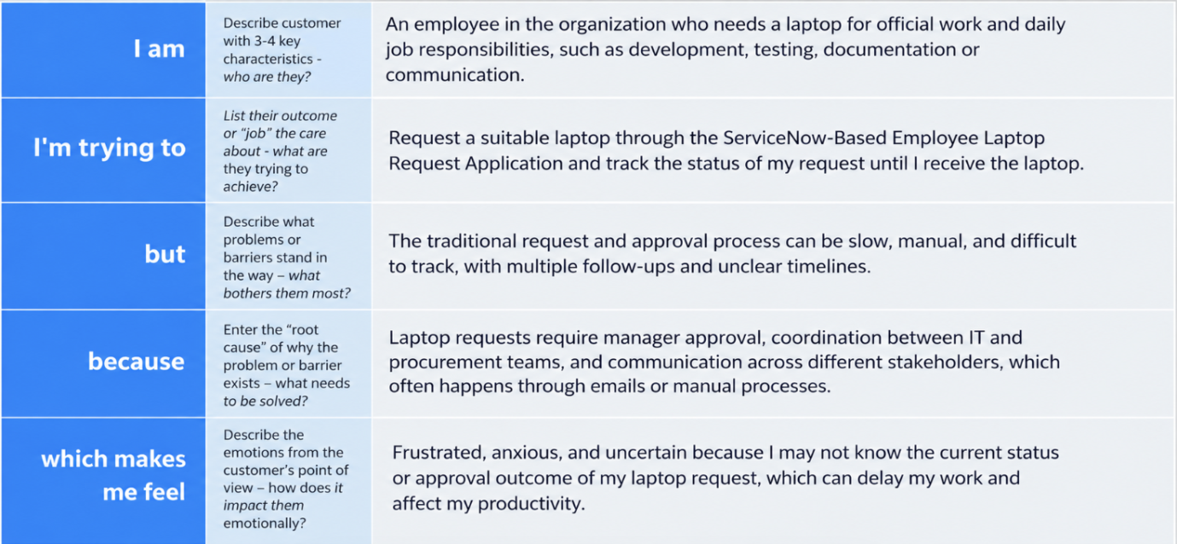
Reference: https://miro.com/templates/customer-problem-statement/
Project Content:
Problem Statement (PS) | I am (Customer) | I’m trying to | But | Because | Which makes me feel
PS-1 | Employee | request a laptop through the Employee Service Catalog | I may need to manually follow up for approval and status updates | the process may not provide automated approval and communication | frustrated and uncertain about when my request will be completed
PS-2 | Manager | review and approve or reject employee laptop requests efficiently | manual coordination can make it difficult to track requests | approval decisions and updates may require repeated follow-up | burdened and concerned about delays or missed requests
PS-1: I am an employee. I’m trying to request a laptop through the Employee Service Catalog, but I may need to manually follow up for approval and status updates because the process may not provide automated approval and communication, which makes me feel frustrated and uncertain about when my request will be completed.
PS-2: I am a manager. I’m trying to review and approve or reject employee laptop requests efficiently, but manual coordination can make it difficult to track requests because approval decisions and updates may require repeated follow-up, which makes me feel burdened and concerned about delays or missed requests.

